

**USER GUIDE**

**SUBMITTED BY:**

MUHAMMAD MAARIG (STUDENT1215488)

HAMMAD HUSSAIN (STUDENT1220233)

MUHAMMAD ZAIN (STUDENT1221139)

SYED MUHAMMAD ANAS JAVED (STUDENT1223877)

**BATCH CODE**

1980G2

**FACULTY**

SIR SOHAIL ALI

**COORDINATOR**

SIR ZEESHAN AHMED

**HOME PAGE**

**OUR HOME PAGE CONTAIN**

1. **LOGO**
2. **HOME**
3. **ABOUT**
4. **THERAPY**
5. **GALLERY**
6. **CONTACT US**
7. **FEEDBACK**

**HOME PAGE**

**OUR HOME PAGE CONTAIN**

1. **LOGO**
2. **NAVIGATION BAR**
3. **MAN EXERCISE**
4. **WOMAN EXERCISE**
5. **SUITABLE FOOTER**
6. **QUERIES LINK**
7. **GALLERY**
8. **ABOUT**
9. **CONTACT US**
10. **FEEDBACK**
11. **TO GET DOWNLOAD AS PDF OR DOC FILE**

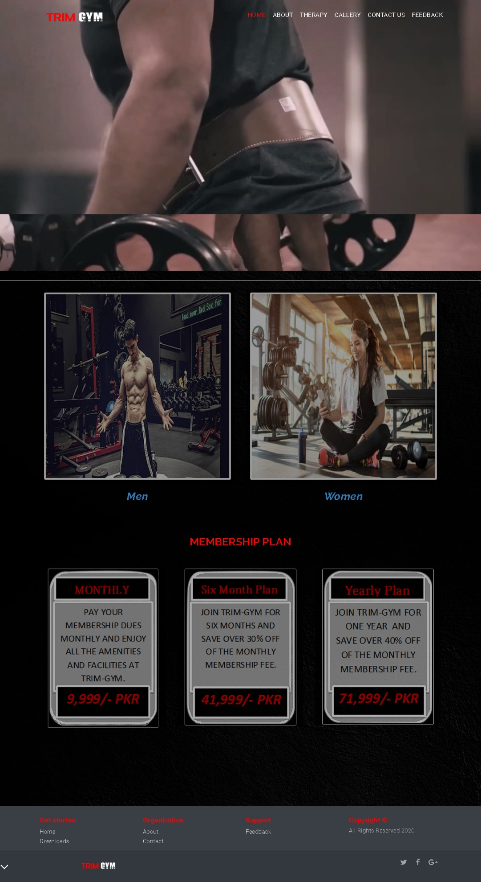

**CONTACT US PAGE**

**OUR CONTACT US PAGE CONTAINS**

1. **NAVIGATION BAR**
2. **SITE MAP**
3. **FOOTER**

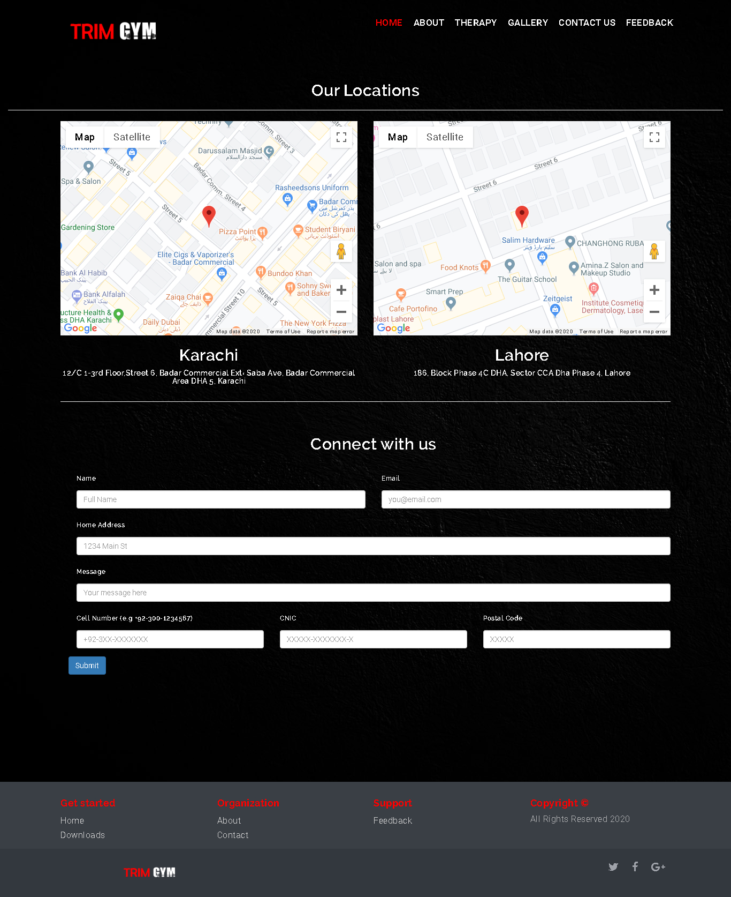

**ABOUT US PAGE**

**OUR ABOUT US CONTAINS**

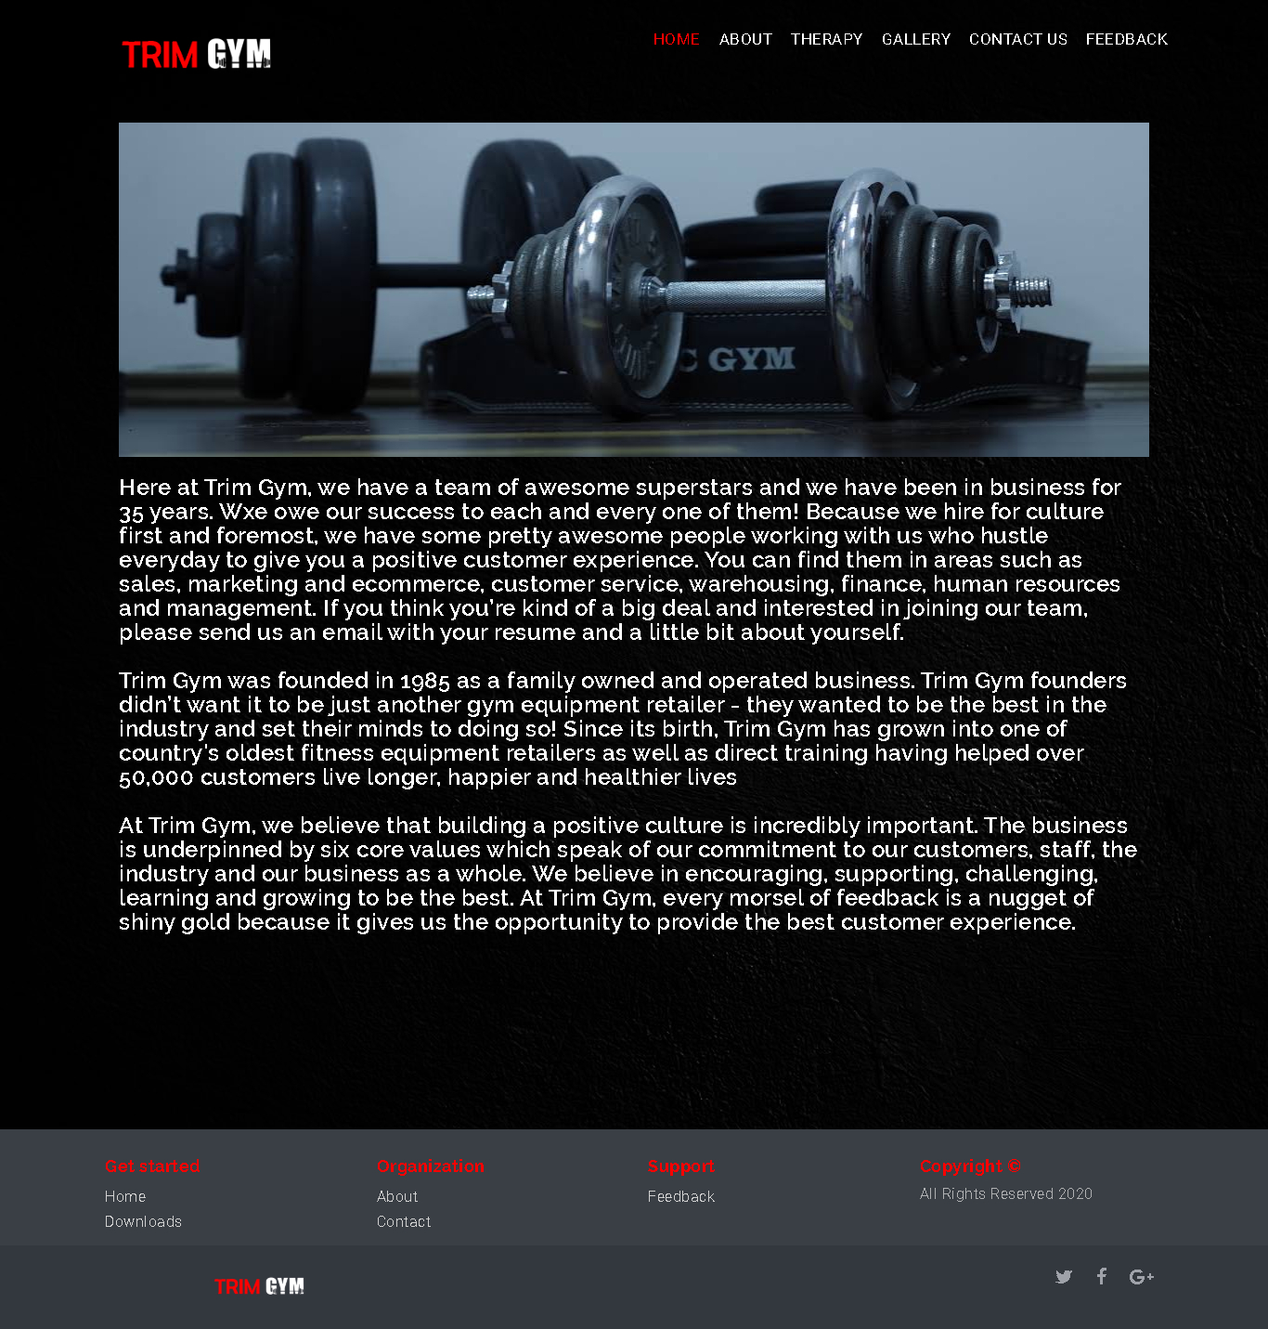

**GALLERY**

**OUR GALLERY PAGE CONTAINS**

1. **NAVIGATION BAR**
2. **EXERCISE IMAGES**

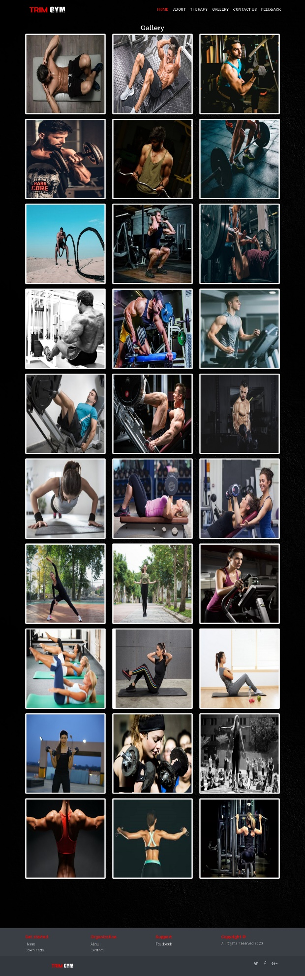

**MAN EXERCISE**

1. **ARMS**
2. **CHEST**
3. **BACKWINGS**
4. **CARDIO**
5. **LEGS**
6. **CORE**

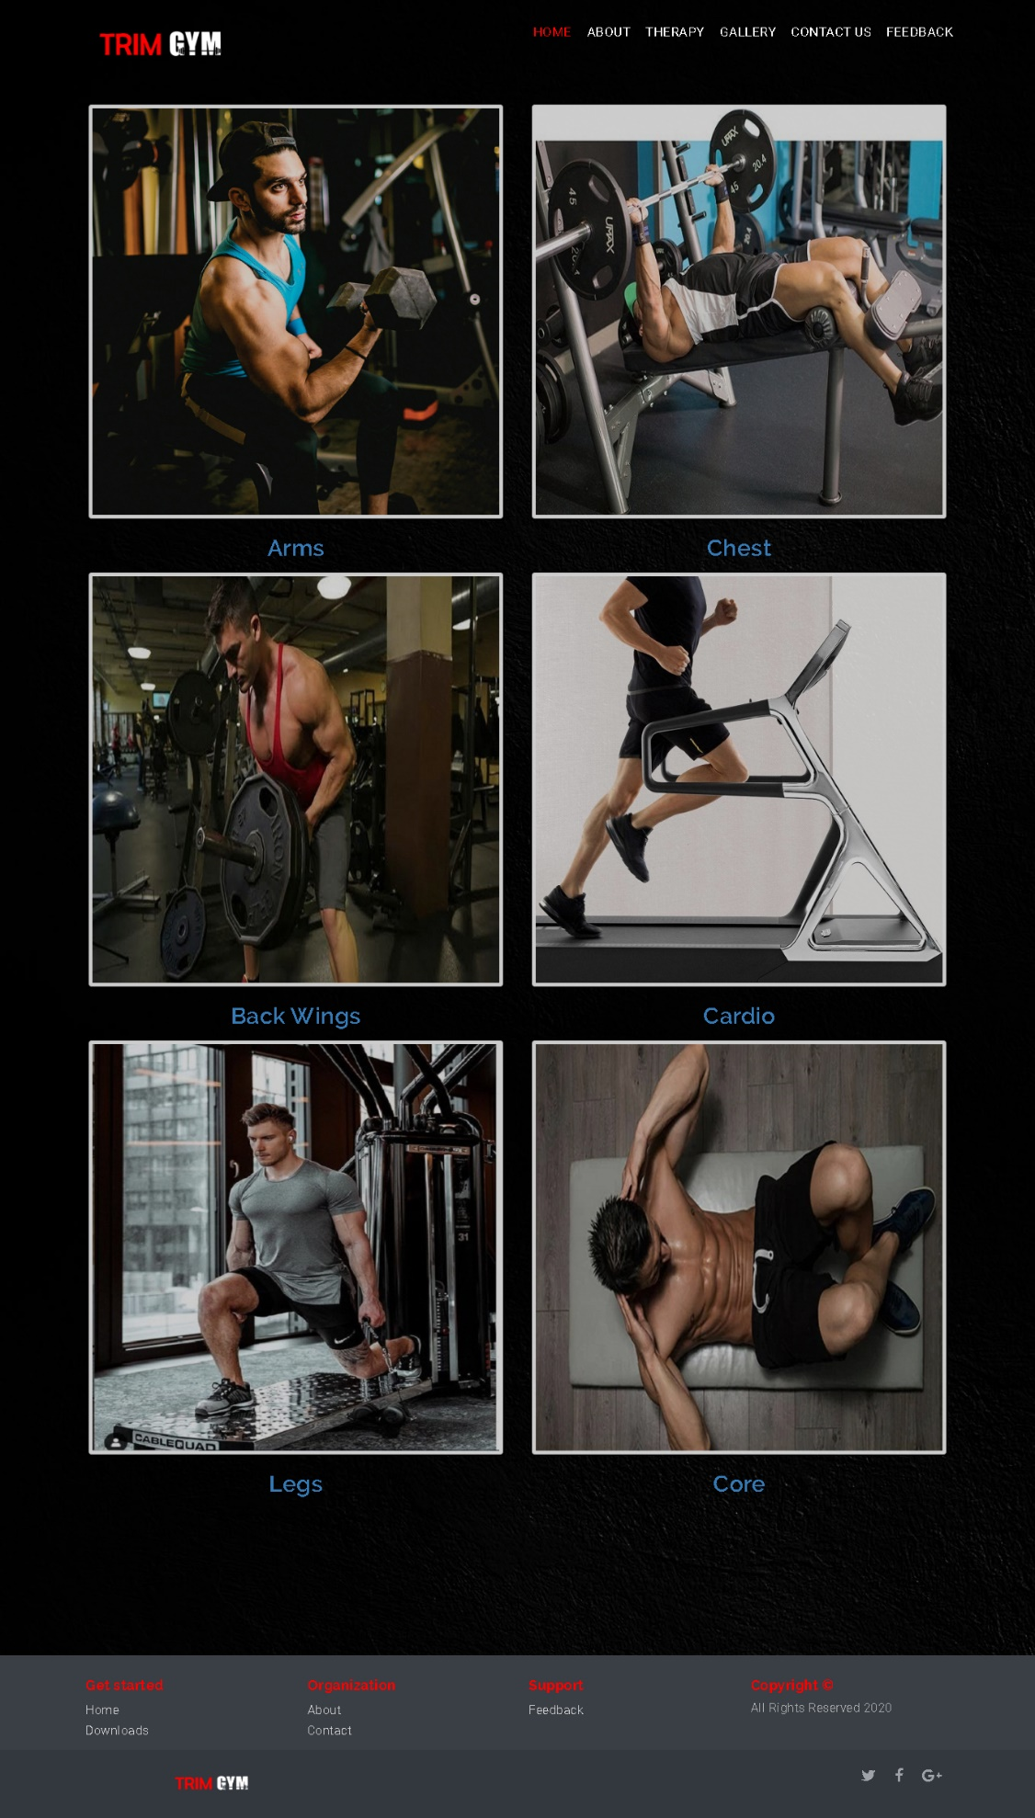

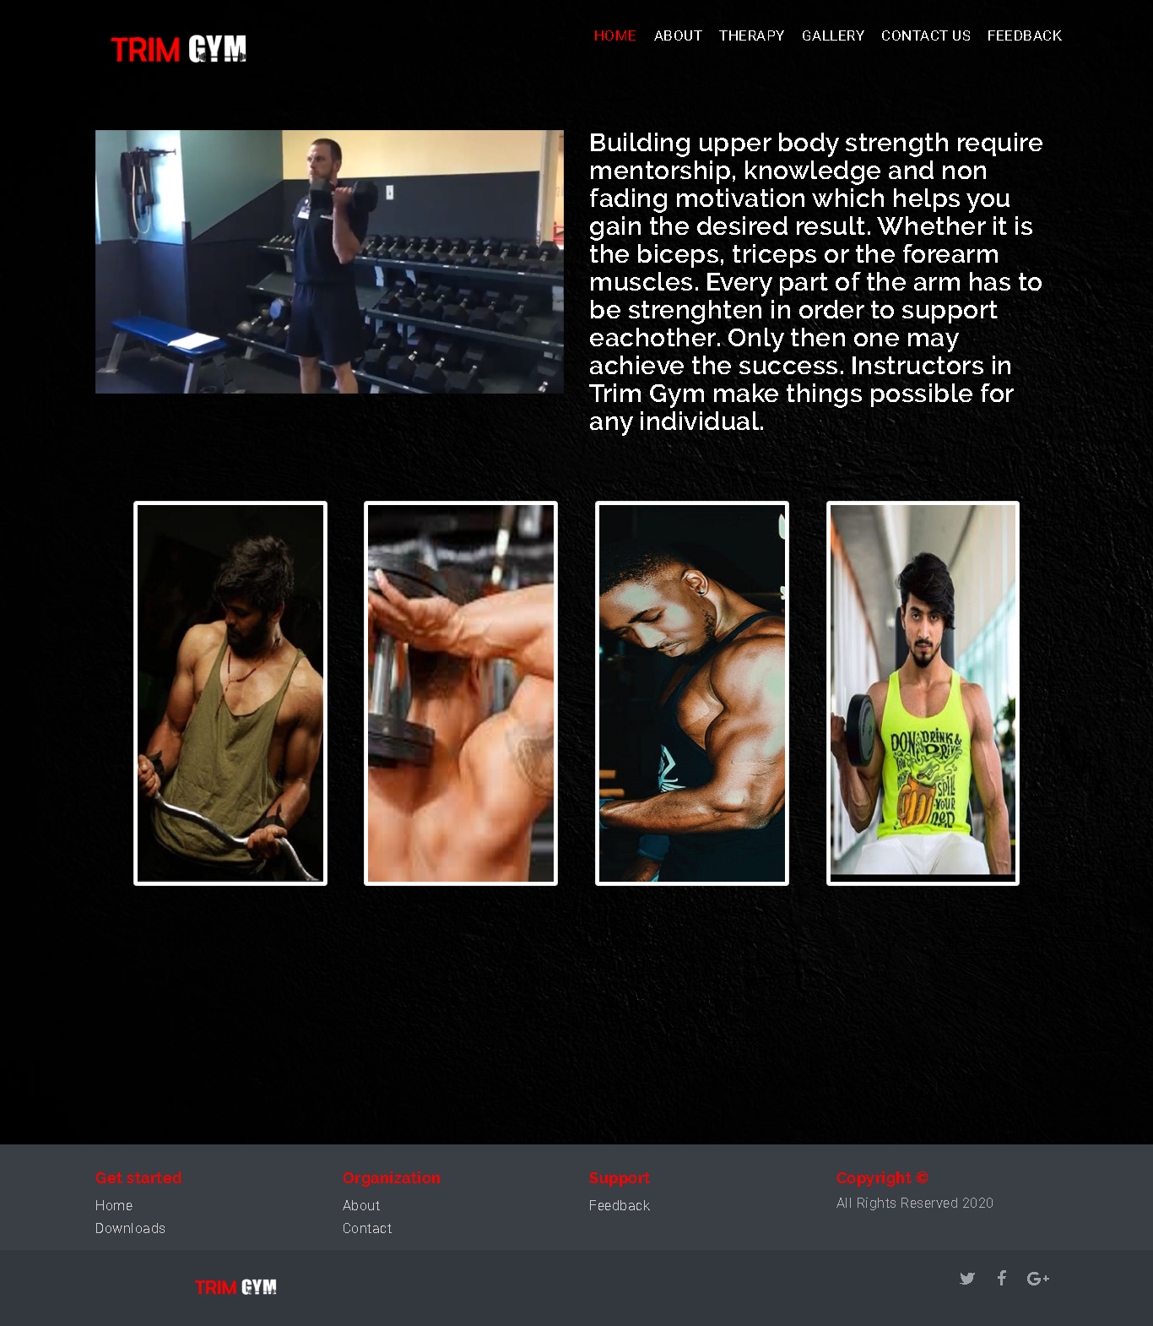

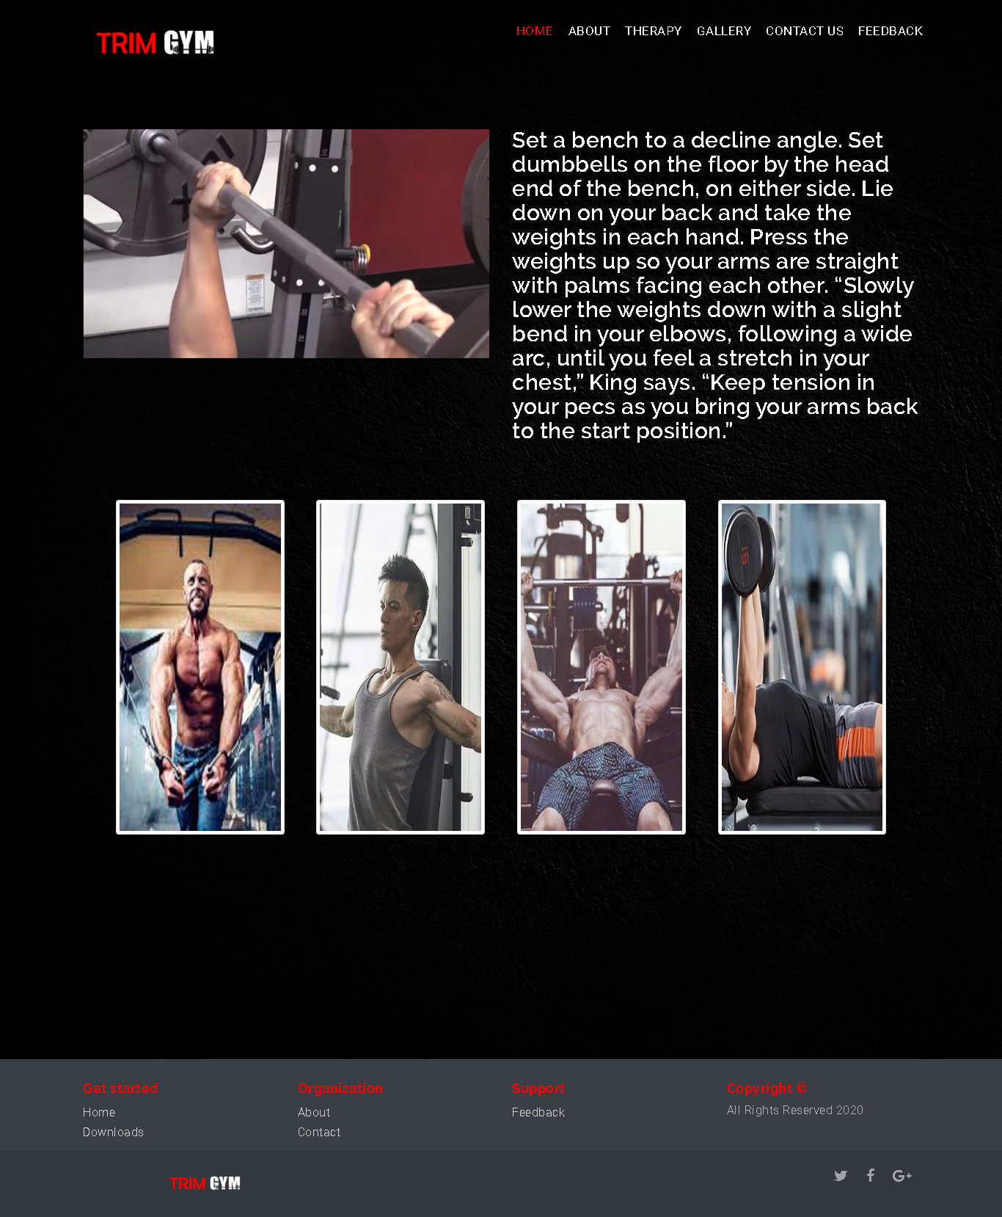

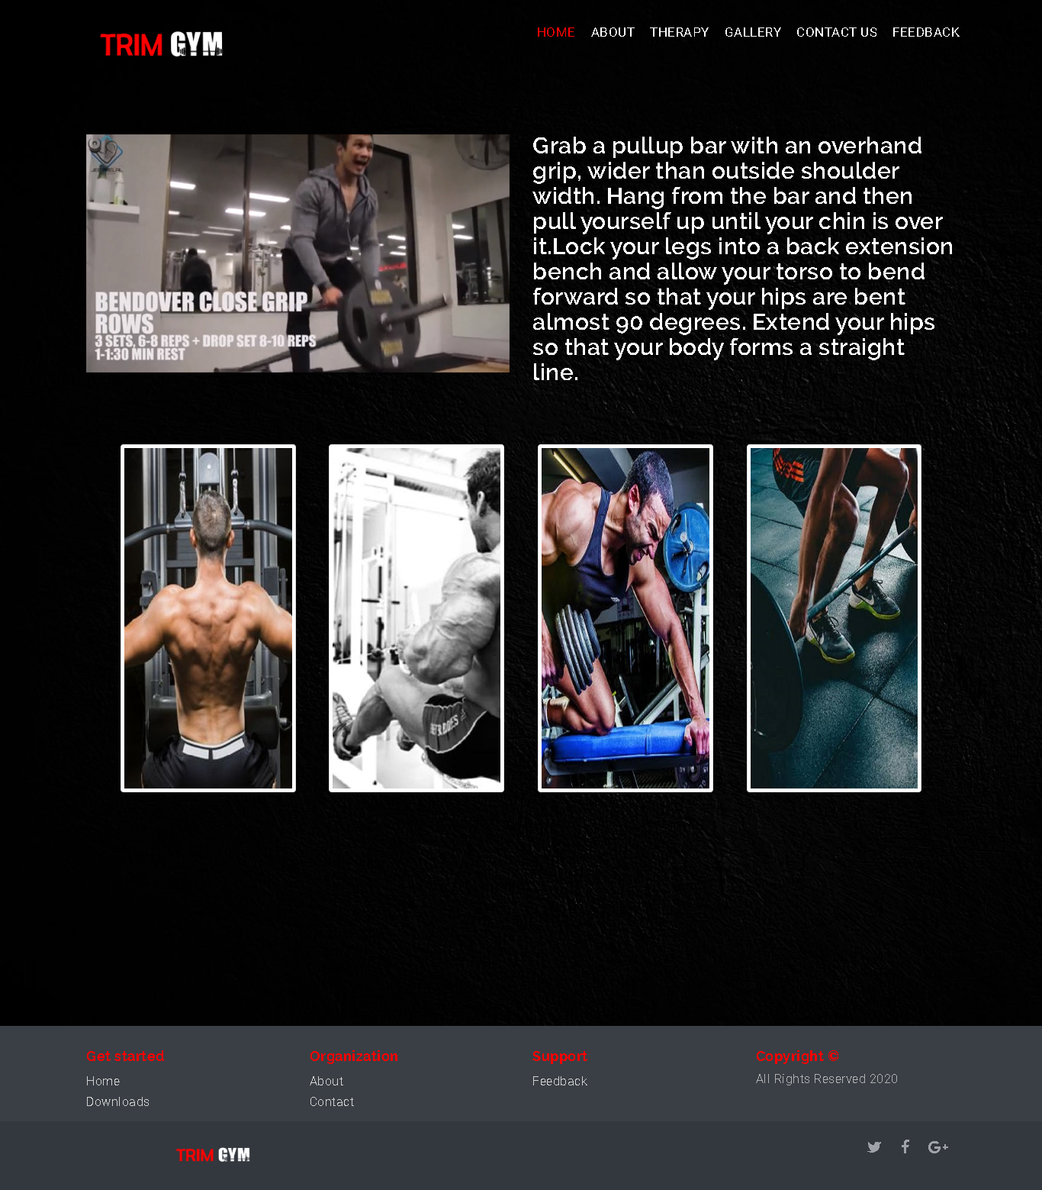

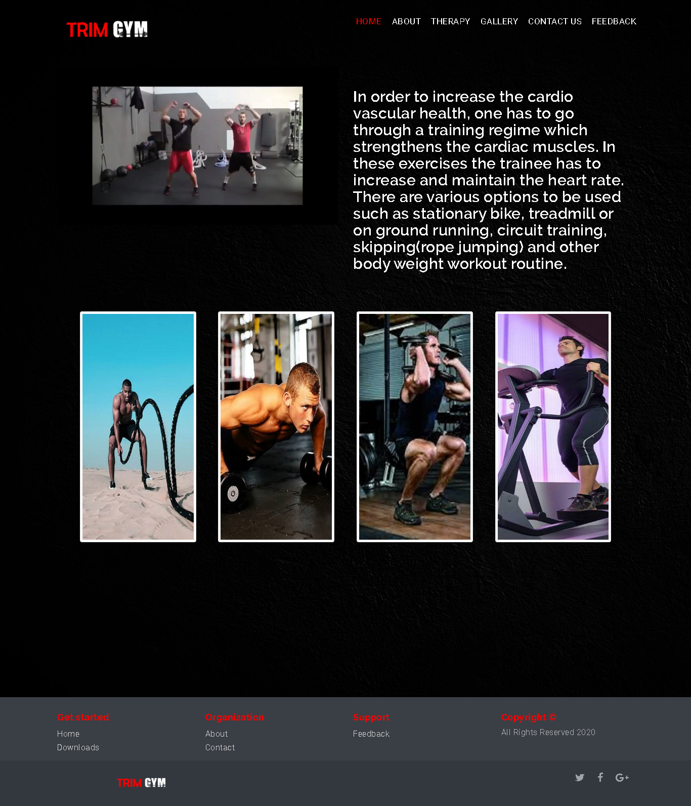

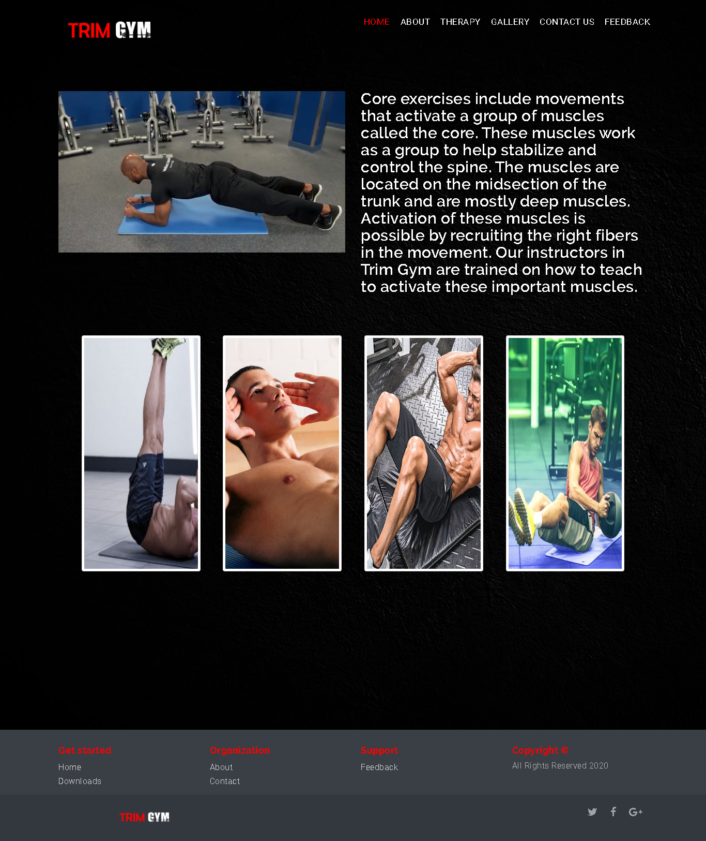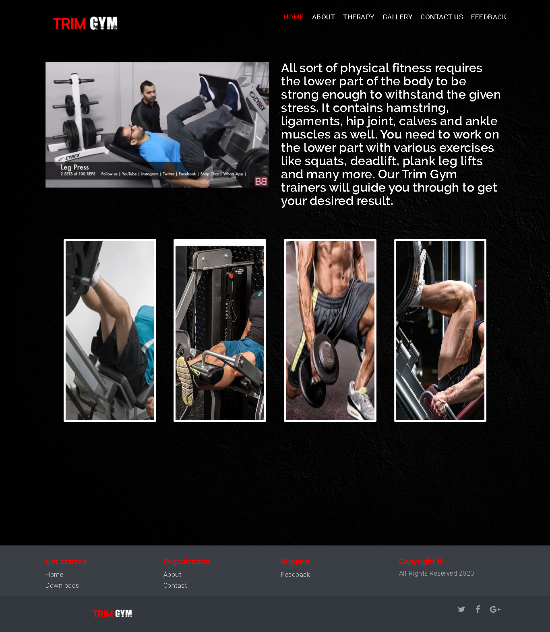

**WOMAN EXERCISE**

1. **ARMS**
2. **CHEST**
3. **BACKWINGS**
4. **CARDIO**
5. **LEGS**
6. **CORE**

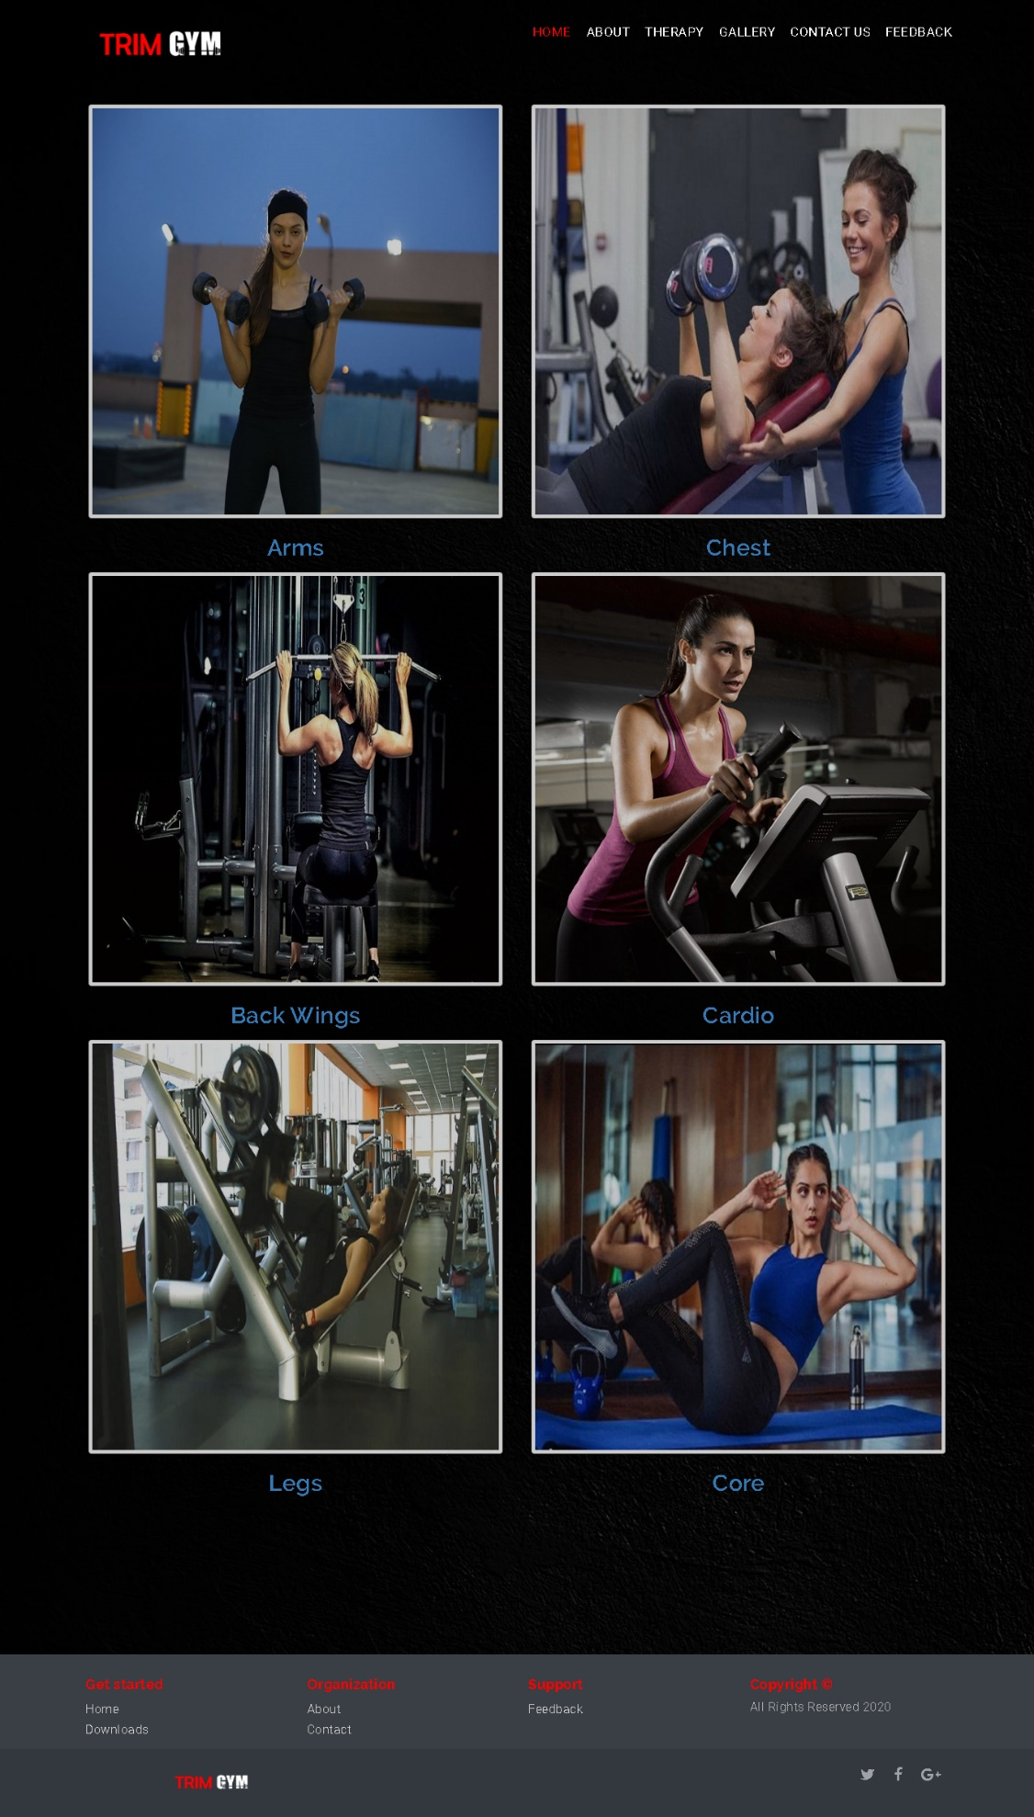

**THERAPY**

1. **CLINICAL NUTRITION**
2. **PILATES**
3. **REHABS**
4. **THERAPY**



**FEEDBACK**

